Important

The (conference name) has been approved for AMA PRA Category 1 CreditTM. Educational activities approved for AMA PRA Category 1 CreditTM must adhere to the Standards for Integrity and Independence in Accredited Continuing Education adopted by The Accreditation Council for Continuing Medical Education (standards included for reference).

You have been asked to review content material provided which may be identified as a potential Conflict of Interest (when individuals have both a financial relationship with a commercial interest and the opportunity to affect the content of CME about the products or services of that commercial interest). It is imperative you complete the attached form accurately and honestly. Participants of the conference will be informed of all disclosures and resolutions prior to the activity. They will have the opportunity to report bias detected for any presentation that was approved for AMA PRA Category 1 CreditTM. If significant bias is reported for any presentation, that presentation may not be awarded AMA PRA Category 1 CreditTM.

The Identification and Mitigation of Financial Relationships form you are to complete provides information regarding your role and COI.

Apologies for the busy and lengthy form, but, AMA PRA Category 1 CreditTM is a valuable addition to any continuing medical education offering.

Thank you for your time.

Do not forget to print your name, provide your signature (written or electronic) and date.

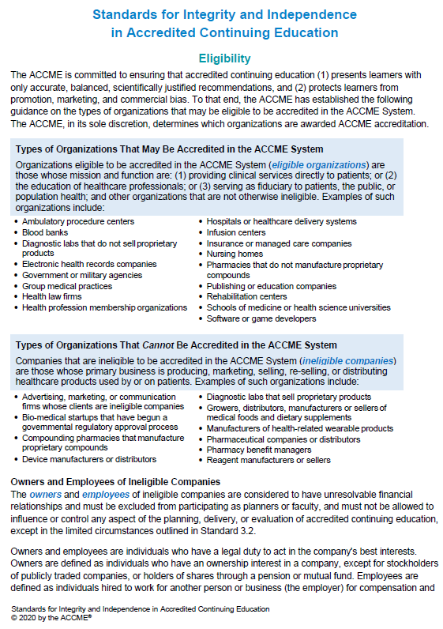

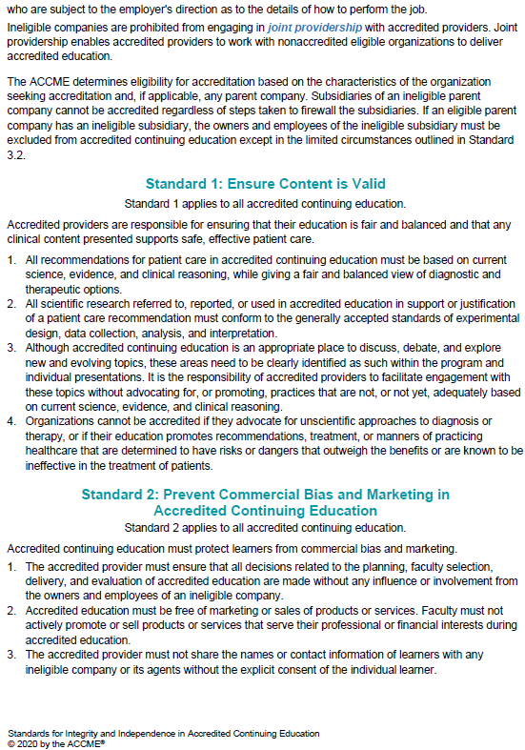
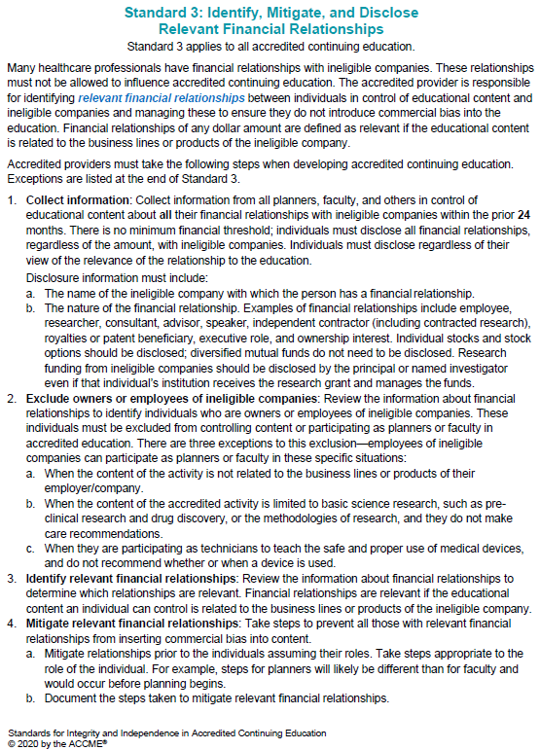
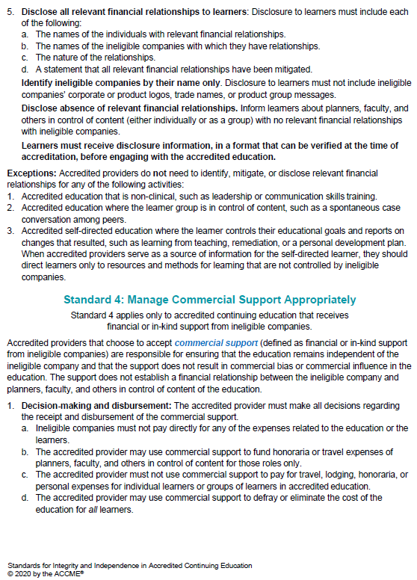

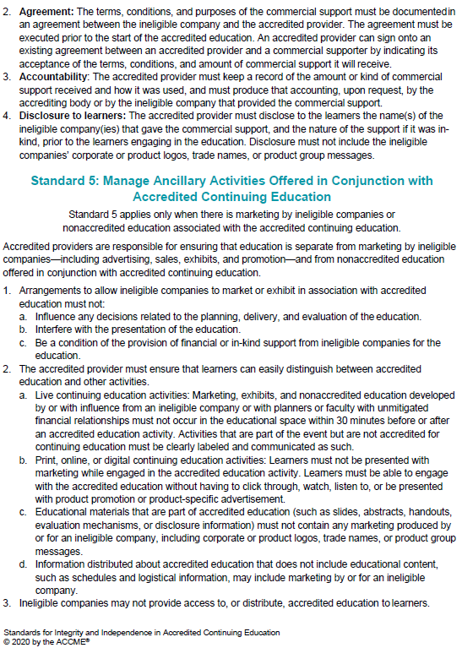



Identification and Mitigation of Financial Relationships
(to be completed prior to the activity)

Activity: | Date:
Speaker: | Topic:
Relationship-Consultant, Speaker’s Bureau, Stock Shareholder, Employment, etc. | Company-Pharmaceutical Co., Equipment Co., Service Co., etc.
Relationship: | Company:
Relationship: | Company:
Relationship: | Company:
Use separate sheet for additional disclosures
In your role as content reviewer for this presentation, is there potential for you to receive monetary gain or loss depending on the outcome of this review? (If no, continue. If yes, please contact the Continuing Medical Education (CME) Office. Yes No

Instructions to Reviewer(s): Please review the attached course materials for the above referenced CME activity, speaker and presentation topic. Your role is to ensure:
1) Activity materials are fair, balanced, and free of bias toward any commercial entity producing, marketing, re-selling or distributing health care goods or services consumed by, or used on patients discussed in the activity prior to the CME Activity.
2) Content relates to health care services and treatment promoting improvements in health care and not a proprietary business interest or commercial interest.
3) Patient treatment recommendations are supported with best available evidence.
4) Studies referenced are scientifically objective and conform to research principles generally accepted by the scientific community.
Definition of a Commercial Interest
Revised 1/19
A commercial interest is any entity producing, marketing, re-selling, or distributing health care goods or services consumed by, or used on, patients. The Accreditation Council for Continuing Medical Education (ACCME), the main accreditation body for CME courses, does not consider providers of clinical service directly to patients to be commercial interest – unless the provider of clinical services owned, or controlled by, an ACCME-defined commercial interest.
A commercial interest is not eligible for ACCME accreditation. Commercial interests cannot be accredited providers and cannot be joint providers. Within the context of this definition and limitation, the ACCME considers the following types of organizations to be eligible for accreditation and free to control the content of CME:
- 501-C Non-profit organizations (Note, ACCME screens 501c organizations for eligibility. Those that advocate for commercial interests as a 501c organization are not eligible for accreditation in the ACCME system. They cannot serve in the role of joint provider, but they can be a commercial supporter.)
Government organizations For-profit hospitals
- Non-health care related companies For-profit rehabilitation centers
- Liability insurance providers For-profit nursing homes
- Health insurance providers Blood banks
- Group medical practices Diagnostic laboratories
ACCME reserves the right to modify this definition and this list of eligible organizations from time to time without notice.
1. Do the instructional materials include recommendations regarding products or services? |  | Yes No
2. Do the financial interests disclosed by the individual with control over content relate to subject matter of the CME activity? |  | Yes No
If “NO” to questions 1 or 2 above, the conflicts of interests are resolved and the review is complete. Print your name, sign, date and
provide any comments below.
If “YES”, according to your review, please answer questions 3-6. Print your name, sign, date and provide any comments below.
3. Are all recommendations involving clinical medicine based on evidence that is accepted within the profession of medicine as reasonably supportive for their indications and contraindications in the care of patients? |  | Yes No  If no, resolution will be completed by CME Office
4. Does all scientific research reference, reported or used in support of patient care recommendations, conform to the generally accepted standards of experimental design, data collection and analysis? |  | Yes No  If no, resolution will be completed by CME Office
5. Are any products or services singularly included in this presentation when other equal, competing products or services are available for inclusion?  If yes, explain: |  | Yes No  If yes, resolution will be completed by CME Office
6. Do materials reviewed include advertising, trade name (logo) or a product group message of a commercial interest?  If yes, explain: |  | Yes No  If yes, resolution will be completed by CME Office
Reviewer’s Name:______________________________________ Signature:____________________________________ Date:_______________
Please Print By placing an “X” on the above line, you are signing this form electronically.
Content Reviewer’s recommendations, if any:___________________________________________________________________________________
For CME Office Use:
Resolution: To help ensure the content of the CME Activity is not influenced by commercial interests, the following action was taken:
Faculty revising content based on recommendation from content reviewer
Faculty documenting best available evidence to support recommendations
Relationship/affiliation does not present a relevant conflict of interest (lecture relationship and topic are incongruent).
Having an alternate person without a COI serve as faculty to present that section of the activity
Other, Explain: ________________________________________________________________________________________________________
Approved: Signature__________________________________________ Date:____________________________

Please return this completed form to (Your Name/Address) along with the supporting documentation:
(Your E-mail)

