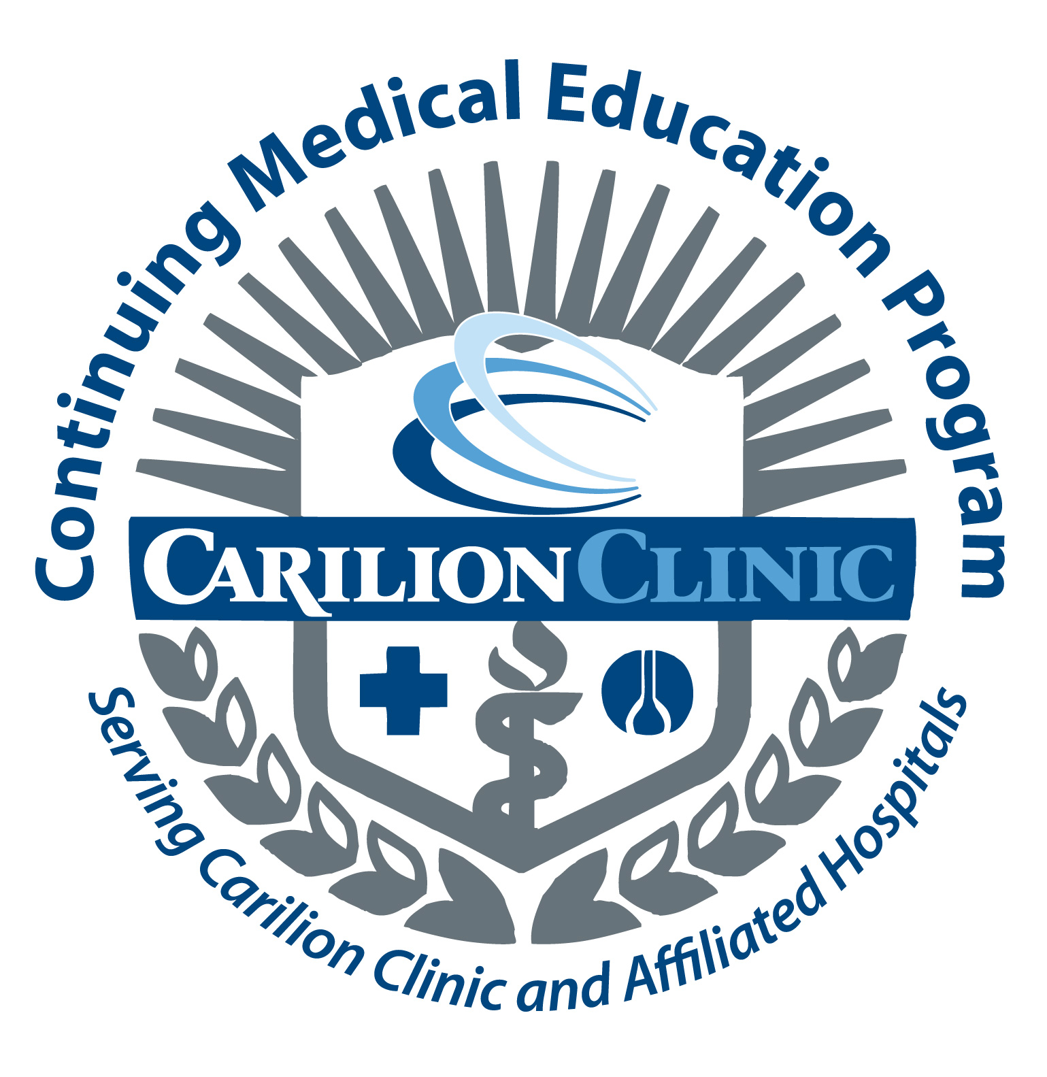

Speaker Commitment Template

Activity:__________________________________________

Date:_____________________________________________

- Verify commitment to speaker (can you do a presentation)
___________________________________/________________________________
Activity Day/Date

- The Planning Committee has developed some learning objectives on your presentation entitled "______________________________" from which our participants will benefit. Think of the objectives in this form "At the conclusion of your presentation we want the audience to be able to":
List_________________________________________________________________
Describe_____________________________________________________________
Recognize____________________________________________________________
Please tweak these objectives and/or provide two-three learning objectives which best verify the content of your presentation.

- We want to present a top notch conference which includes good handouts for our participants. Can you commit to having handouts by __________(Date)?

- We need to have handouts/presentation materials (could be your powerpoint presentation) by ________________(Date) in order to go into a bound binder/syllabus and CD.

- This activity will receive Category 1 credit through Carilion Clinic CME Program. Activities receiving Category 1 CME credits must adhere to specific elements regarding honorarium and disclosures.

- An honorarium of $ ___________ will be paid to you plus expenses for lodging and travel (mileage @ .70 cent/mile or coach airfare).
Honorarium Guidelines:
Carilion Clinic Faculty Nominal Stipend ($100 gift certificate)
Local Speaker $500.00
Regional Speaker (driving distance) $750
National Speaker $1000/day
Honorariums outside guidelines require a letter of request to the Director of CME

- We will need you to complete a disclosure form. Guidelines developed and implemented by the Accreditation Council for Continuing Medical Education and the Office of the Inspector General require disclosures of any relevant financial relationships/affiliations with any ineligible companies which may affect your ability to impartially present the content of your presentation. If there is conflict of interest, the best way to mitigate it is with evidence based data.

- The Carilion Clinic CME Office will be in touch and provide a packet of the information and forms we have discussed.

updated 11/25

