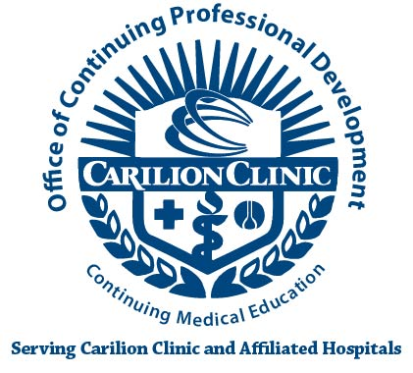
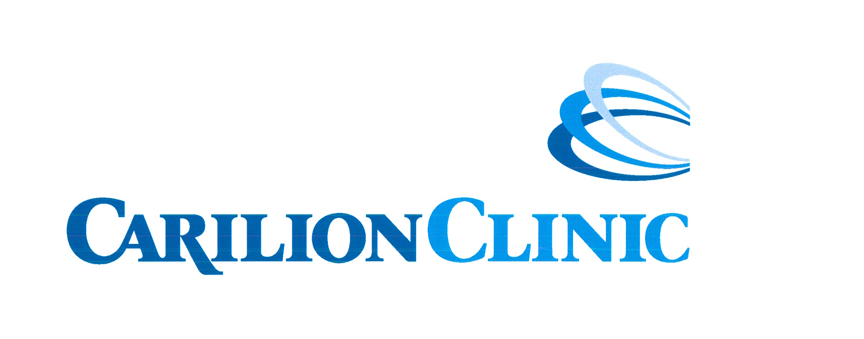
Post-Activity Meeting Report

Activity:

Activity Date:

Activity Coordinator:

Physician Champion:

Attendees of Meeting:

Date of Meeting:

- Core Curriculum (please provide a list of lectures with dates where the curriculum was addressed):

- Outcomes:

- Strengths:

- Weaknesses:

- Was the Carilion CME Program Mission met:

- Barriers:

- Change:

8. What was learned and what adjustments can be made for improvement:

Post-Activity Meeting Report

Activity: 62ndAnnual Spring Symposium

Activity Date: March 18-19, 2012

Activity Coordinator: Jane Doe

Physician Champion: Dr. John Smith

Attendees of Meeting: Dr. Smith, Jane Doe, Amber Franklin, Gerald Lambert

Date of Meeting: April 8, 2012

1. Core Curriculum addressed:
Cardiology (6), Diabetes (3), Pulmonary (3), Infectious Disease (5), Allergy (2), Cancer (2), GYN (2), Rheumatology (2), Gastroenterology (3), Professionalism (1), Communication (2), Sleep Disorders (1), Clinical Pathology (10) were presented (see attached list).

- Outcomes:
The overall evaluations were excellent. Speakers were given high evaluations (Excellent – Very Good) and it was felt they were on target with the information provided to the primary care audience in attendance. The feedback both verbal and written expressed that this activity provided quality continuing medical education that introduced new technology, educational techniques, and updated information that serves to increase knowledge and improve clinical skills.

- Strengths:
a. The diversity of the topics provided knowledge that suited the target audience.
b. The location offered state-of-the-art audiovisual equipment (used ARS) and is
central to all local physicians

- Weaknesses:
a. Commitment by speakers to provide requested information and forms.
b. Participants not providing feedback. Complaints about not having topics presented; but
those participants complaining do not include topics on their evaluation form.

- Was the Carilion CME Program Mission met:
Feedback from participants indicates the topics increased physician knowledge and competence. It is anticipated physicians will report greater confidence in their approach to clinical problems or express their intent to change their behavior. It is felt physicians will apply newly acquired strategies in their practice. Evaluation within the setting of clinical practice; we expect performance parameters to show improvement or favorable impact on targeted patient outcomes to be demonstrated.

- Barriers:
a. Time constraints – continuing problem.
b. The organization wants physicians informed and on the cutting edge. With the time
constraints on physicians’ time the educational interventions are planned (time, location, etc.) to accommodate their schedules.
c. Gaps/needs – the physicians’ perceptions are that they “have no gaps/needs”.
d. Promotion is critical to improve attendance (early, visible, etc.).

- Change:
The topics were selected to change knowledge and competence. Verbal and written comments indicate physicians acquired knowledge and feel more competence in diagnosis, treatment as well as when to transfer to another discipline.

8. What was learned and what adjustments can be made for improvement:
Nothing new, continues to be a problem getting needed information from speakers. One could
have the physician champions address the issue with the speakers.

Carilion Clinic’s Continuing Medical Education

Mission Statement
Carilion Clinic's CME Program:
- Carilion Clinic's CME Program believes that continuing medical education favorably impacts the quality of healthcare and serves as a mechanism for continuous improvement.
- The purpose and mission of Carilion Clinic's CME Program is to provide quality continuing medical education that introduces new technology, educational techniques, and updated information that serve to increase knowledge and improve clinical skills.
- The scope of topics is necessarily broad to reach primary care physicians, specialists and sub-specialists. Participants are from many small, rural hospitals, larger secondary hospitals, regional medical centers and tertiary care providers in southwest Virginia
- The activities range from one-hour weekly conferences (Medical Grand Rounds) to one and two day conferences.
- As a major educational institution in western Virginia, we feel an obligation to encourage smaller hospital and medical societies without their own CME accreditation to jointly sponsor CME within the Essential Areas and policies of The Medical Society of Virginia.
- The Carilion Clinic’s CME Program through collaborative efforts strives to continuously design and implement innovative educational and non-educational interventions in order to increase physician knowledge, competence, performance or patient outcomes. We anticipate the physicians will report greater confidence in their approach to clinical problems or express their intent to change their behavior. We expect they will apply newly acquired strategies in their practice. Evaluation within the setting of clinical practice, we expect performance parameters to show improvement or favorable impact on targeted patient outcomes to be demonstrated.
Carilion Clinic:
- Carilion Clinic exists to improve the health of communities it serves.
- Carilion Clinic's CME Program provides opportunities through continuing medical education for physicians to address the educational needs of physicians, and favorably impact the quality of healthcare in the communities it serves.

