**Carilion Clinic’s Continuing Medical Education Program**

**CME Application Process Instructions**

* Contact your appropriate CME Program Specialist to request a link for the CME Application:

Paula Robertson at 540-224-6806 pgrobertson@carilionclinic.org

Carol Gibson at 540-224-5418 [chgibson@carilionclinic.org](mailto:chgibson@carilionclinic.org)

* The link will be e-mailed along with appropriate forms. Each link has an assigned number.

**DO NOT CLICK ON THE LINK**

* Copy the link and open Mozilla Firefox browser, then paste the link in the address line of the browser. 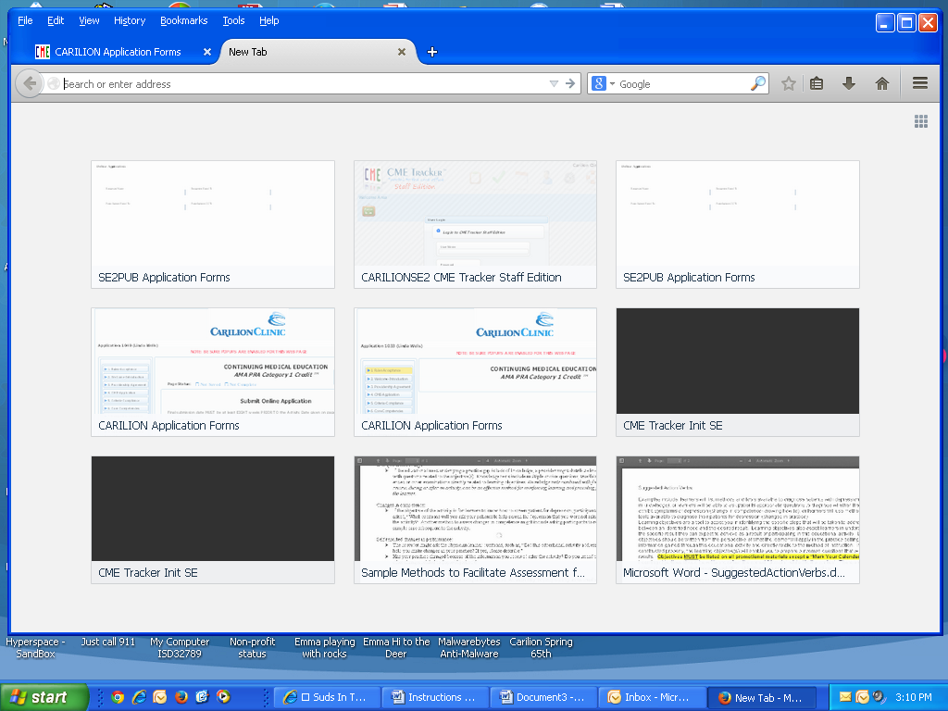

*🡺*

Please read before starting application.

Each page must be completed before you are allowed to go to the next page. You may go back to prior pages at any time. Remember when making any changes – you must save or data will be lost.

Indicates Required Fields. If not completed you will not be allowed to go to the next page.



Place cursor over the question mark and detailed information will pop up.



There will be pages that will require uploads. It is important that you have the materials in a document (word or PDF) prior to starting your application. *Suggestion: Create a folder with all the documents you will need to attach.*

1. Planning Committee Member Disclosures (when multiple forms scan and put in a single document)
2. Needs Assessments minimum of 2 (when multiple forms are used, scan and put in a single document)
3. Letter if honorarium is outside guidelines
4. Faculty Curriculum Vitae
5. Evaluation Form if you will not be using CME Evaluation Form
6. Activity Agenda
7. Promotional Materials
8. Projected Activity Budget

When an upload is required click on “Browse” (which takes you to your documents), find the appropriate document, and click “Open” which takes you back to the application. *Check the title of the document to make sure it is the correct one*, once you are sure click “Upload”. You will see  🗹UPLOADED

One person in the application at a time.

**Do not cut and paste from a document (e.g. objectives). This will cause the system to lock up and could hold up the processing of your application.**

**Application Pages:**

**Page One: Rules – Acceptance**

* Enter the activity date (Note: if you click on the calendar icon the dates outside the parameter are grayed). If the date is entered manually and is outside the 8 week parameter an alert will pop up alert, caution, exclamation, exclamation mark, sign, triangle, warning icon*Date Not Valid.* Date must be at least 8 weeks from current date.
* List of materials needed with the application
* List of materials needed 30 days after the activity
* Rules to Remember
* Save-the-Date Postcard suggestions
* Accept/Decline buttons.
* **Save Page** button – to save page before exiting (e.g. going to lunch and will resume completing application after lunch)
* **Page Completed** button – to proceed to next page after required items are completed

**NOTE:** The “Page Completed button” will automatically push to the top of the page; navigate to the table of contents (upper left of page) and click on the next page available which changes from grayed-out to bold

**Page Two: Welcome – Introduction**

* Read the Introduction
* “I have read and understand” must be checked
* **Save Page** button – to save page before exiting (e.g. going to lunch and will resume completing application after lunch)
* **Page Completed** button – to proceed to next page after required items are completed

**Page Three: Providership Agreement**

* Requester’s information must be completed
* **ALL** planning committee members, support staff and anyone who has input to the content of the activity.
* Upload of **ALL** persons who have input to the content of the activity.
* List of materials needed 30 days after the activity – ***be aware if the post activity materials are not received, credit(s) will not be awarded – approval of credits are null & void if the post activity material is not submitted.***
* Agreement with e-Signature
* Accept/Decline buttons.
* **Save Page** button – to save page before exiting (e.g. going to lunch and will resume completing application after lunch)
* **Page Completed** button – to proceed to next page after required items are completed

**Page Four: CME Application**

* Complete all questions
* **Save Page** button – to save page before exiting (e.g. going to lunch and will resume completing application after lunch)
* **Page Completed** button – to proceed to next page after required items are completed

**Page Five: Criteria – Compliance**

* Complete all questions
* **Save Page** button – to save page before exiting (e.g. going to lunch and will resume completing application after lunch)
* **Page Completed** button – to proceed to next page after required items are completed

**Page Six: Core Competencies**

* Complete all questions
* Target Audience (***if the primary audience is nurses complete application for Contact Hours for Nursing***)
* Upload Needs Assessments (2 minimum)
* **Save Page** button – to save page before exiting (e.g. going to lunch and will resume completing application after lunch)
* **Page Completed** button – to proceed to next page after required items are completed

**Page Seven: Measurable Objectives**

* Complete Measurable Objectives.
* You will be instructed to open in Adobe Acrobat. The below prompt will let you know if you are not in Adobe Acrobat to click on the tab “x” of the document displayed and not the closure “x” in the top right corner.



* ***Remember unacceptable verbs include: Understand, Learn, Know, Believe (unless the activity has a pre and/or post test.***
* May cut and paste objectives from a document.
* **Save Page** button – to save page before exiting (e.g. going to lunch and will resume completing application after lunch)
* **Page Completed** button – to proceed to next page after required items are completed

**Page Eight: Faculty**

* Complete Faculty Information
* Upload a letter if honorarium is outside guidelines
* Upload faculty CV
* **Save Page** button – to save page before exiting (e.g. going to lunch and will resume completing application after lunch)
* **Page Completed** button – to proceed to next page after required items are completed

**Page Nine: Outcomes – Educational Format – Evaluation**

* Complete Desired Results/Outcomes
* Complete Educational Format(s)
* Complete Evaluation Information
* If viewing Example Evaluation Methods – Please **Save Page** before clicking on Example Evaluation Methods
* Upload Evaluation form if not using CME Evaluation Form
* **Save Page** button – to save page before exiting (e.g. going to lunch and will resume completing application after lunch)
* **Page Completed** button – to proceed to next page after required items are completed

**Page Ten: Barriers – Agenda – Promotional Materials – Budget**

* Complete Barriers Information
* Upload Agenda
* Upload Promotional Materials
* Upload Projected Activity Budget
* **Save Page** button – to save page before exiting (e.g. going to lunch and will resume completing application after lunch)
* **Page Completed** button – to proceed to next page after required items are completed

**Page Eleven: Financial Support**

* Complete Financial Support Information
* **Save Page** button – to save page before exiting (e.g. going to lunch and will resume completing application after lunch)
* **Page Completed** button – to proceed to next page after required items are completed

**Page Twelve: Criteria for Commendation**

* Complete the sections for each criteria that is appropriate for your department making sure to complete all questions under that criteria section
* **Save Page** button – to save page before exiting (e.g. going to lunch and will resume completing application after lunch)
* **Page Completed** button – to proceed to next page after required items are completed

**Page Thirteen: Saving – Submission**

* It is suggested you go back and review each page before submitting the application, as once submitted it is no longer available to you.
* ***Save Application as a PDF to your computer for future reference before clicking on the Submit Application button***.
* Submit Application

**If you have not received notification / approval of your CME Application within 10 business days, please contact the appropriate CME Program Specialist or the** [***CMEOffice@carilionclinic.org***](mailto:CMEOffice@carilionclinic.org)**.**

**Paula Robertson**

**540-224-6806**

**Carol Gibson**

**540-224-5418**